# [***Law & Order: Organized Crime EP: A Reflective Stabler Will Seek a 'Different Kind of Solace' in Season 3***](https://tvline.com/lists/law-and-order-organized-crime-season-3-spoilers-stabler-benson/bell-is-bereft/)

By [Kimberly Roots](https://tvline.com/author/kimberly-roots/) / September 21 2022, 2:09 PM PDT



Courtesy of NBC

* [**17**](https://tvline.com/lists/law-and-order-organized-crime-season-3-spoilers-stabler-benson/#comments)

[*Law & Order: Organized Crime*](https://tvline.com/tag/law-and-order-organized-crime/) fans, imagine that we’ve just rolled up our shirt sleeves, turned a chair backwards and settled down across from you in an interrogation room, because we’re going to give it to you straight.

Shortly after TVLine spoke about the series’ upcoming Season 3 with new showrunner [Bryan Goluboff](https://tvline.com/tag/bryan-goluboff/), news broke that he would not continue in that role. And unfortunately, subsequent efforts to talk with his successor, [Sean Jablonski](https://tvline.com/2022/09/01/law-and-order-organized-crime-season-3-showrunner-sean-jablonski/) (*Nip/Tuck*, *Law & Order*), ahead of the show’s return were fruitless. So, bottom line? This preview of *OC* Season 3 will give you the gist of what’s to come, but some of the particulars may change as the show moves through its forthcoming episodes.

Is the situation ideal? Nope. But neither was Stabler’s undercover beard, and we got through *that* together. So ahead of the three-way *Law & Order*/*SVU*/*OC* crossover premiere starting at 8/7c Thursday, **check out the exclusive premiere photo above**, then **scroll through the list below for some ideas about what awaits Stabler, Bell & the gang (and *SVU*‘s Benson, of course) in the near future**.

## **Stabler's sacrifices**



**Photo : Courtesy of NBC**

After the dust from the three-way premiere settles — by the way: for that night only, *Organized Crime* will air in the 8 pm slot, followed by *SVU* and then *Law & Order* — Chris Meloni’s Stabler will find himself living alone for the first time since his return to New York City. “He just dropped Eli off in college in California. His mother’s staying with his other daughter, and he’s in an empty nest,” Goluboff said. “He’s got a lot of time to think about his life and what he’s doing.” Viewers will remember that Season 1 was all about seeking retribution for wife Kathy’s murder, and Season 2 focused on his undercover work; Season 3, however, will find Elliot “trying to figure out, ‘Can I actually go to work and come home and have a life and be a full person? Is that possible for me?'” the EP previews. “He’s really looking at his life and the sacrifices he’s made to do this job correctly.”

## **Bell is bereft**

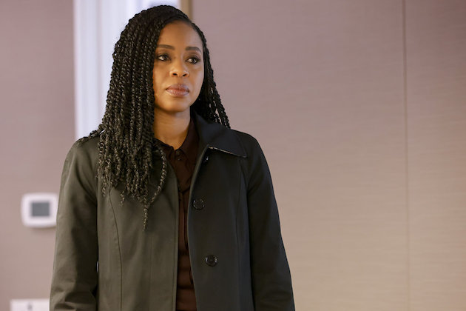

**Photo : Courtesy of NBC**

Stabler’s boss isn’t in a much better place, Goluboff said. At the end of Season 2, Bell’s wife, Denise, left and took their infant son with her, leaving the sergeant “in her own version of an empty nest. She’s trying to get Denise back. And her and Stabler, that squadron just becomes their home, in a way. It’s their refuge, and their unit becomes sort of a family out of necessity, because their lives are kind of empty right now.” On the bright side? “What we have left is our work,” he added, speaking for the characters, “so we’re going to really kick ass in our work. Let’s take it out on the bad guys.”

## **Let it ride!**

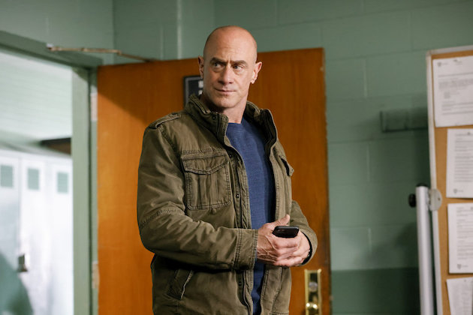

**Photo : Courtesy of NBC**

Season 3 will center on the opening of New York City’s first casino, “which is mobbed-up from the first shovel in the ground to the hooker working with the businessman in the penthouse,” Goluboff previewed. Real estate scion Teddy Silas and his wife Pearl are “this glamorous, young, hip couple” whom Teddy’s highly influential family entrusts with the project, he added. Look for Stabler to find some commonalities between himself and Pearl, whom he’ll slowly work on to make sure “that this casino runs in a clean way and keeps all the crime out.”

Goluboff also said that the season will pivot between the overarching casino story and other, shorter cases: “We really want to give a range of stories and colors, and just make sure we’re doing something thrilling every week.”

## **Will Bernie be back?**

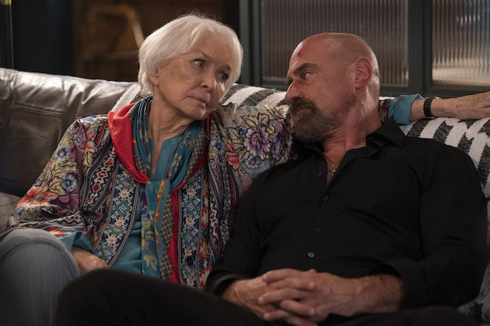

**Photo : Courtesy of NBC**

Though Stabler’s mama isn’t living with him anymore, “she is going to come in for a couple of very special episodes that are going to remind him that he has a family, and even though the nest is empty, he’s still got to take care of his family,” Goluboff said. “She’s going to come back in a big way.”

## **Stabler and Benson's 'dance'**



**Photo : Courtesy of NBC**

When TVLine asked about whether or not we’ll see Stabler continuing in therapy, Goluboff said, “Stabler is going to seek a different kind of solace.” When pressed, the then-showrunner confirmed that there’d be a new woman in the detective’s life. (For what it’s worth, we now hear that that development is up in the air.)

Meanwhile, what about Stabler’s former work wife over at the Special Victims Unit? Goluboff mentioned that Olivia would spend some of [*SVU*‘s Season 24 healing past traumas](https://tvline.com/lists/law-and-order-season-24-spoilers-benson-stabler/) but maintained that “She and Elliot have each other’s backs. She has to lead her squad and be there for everybody, and he has to do the same, and they’re the person each could go to and [say] ‘This is hard. I need to talk to you for a minute,'” he said. He called the former partners’ work together, especially in the premiere, a “dance”: “When they work a case together, that’s, you know, Astaire and Rogers.”